**Experiment : 9**

**Title :** Configure Failover Routing with

Amazon Route 53

**Aim :** Configure DNS failover routing policy for Webservers across AWS Regions.

**Pre-requisites :** AWS Console, Amazon Route 53, Amazon EC2.

**Procedure :**

Steps:

1. Create a Public webserver in region 1.

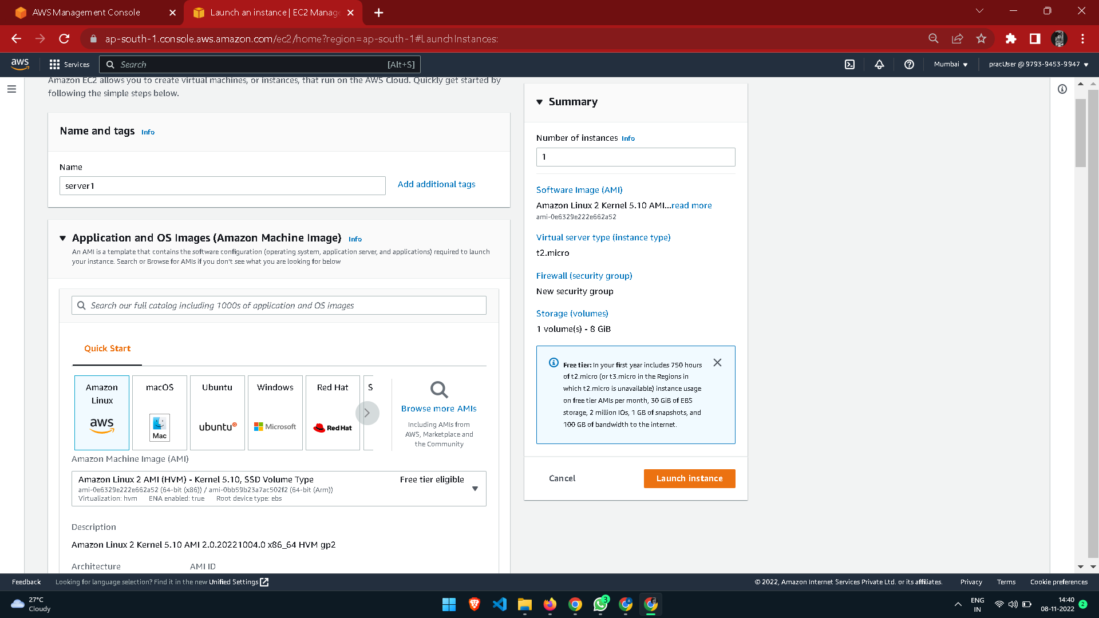

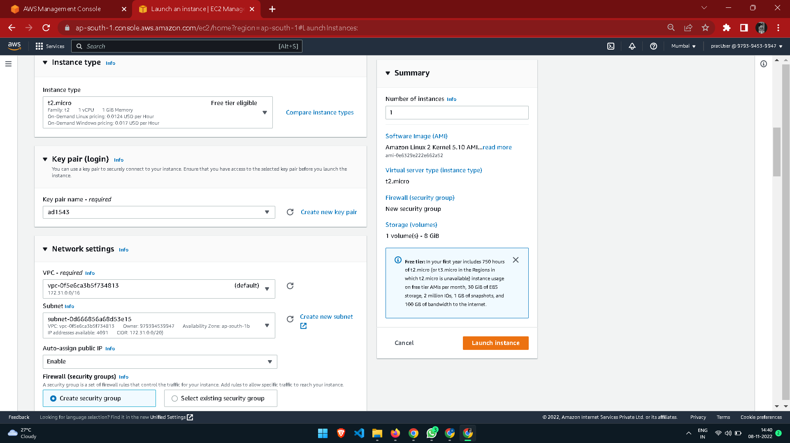

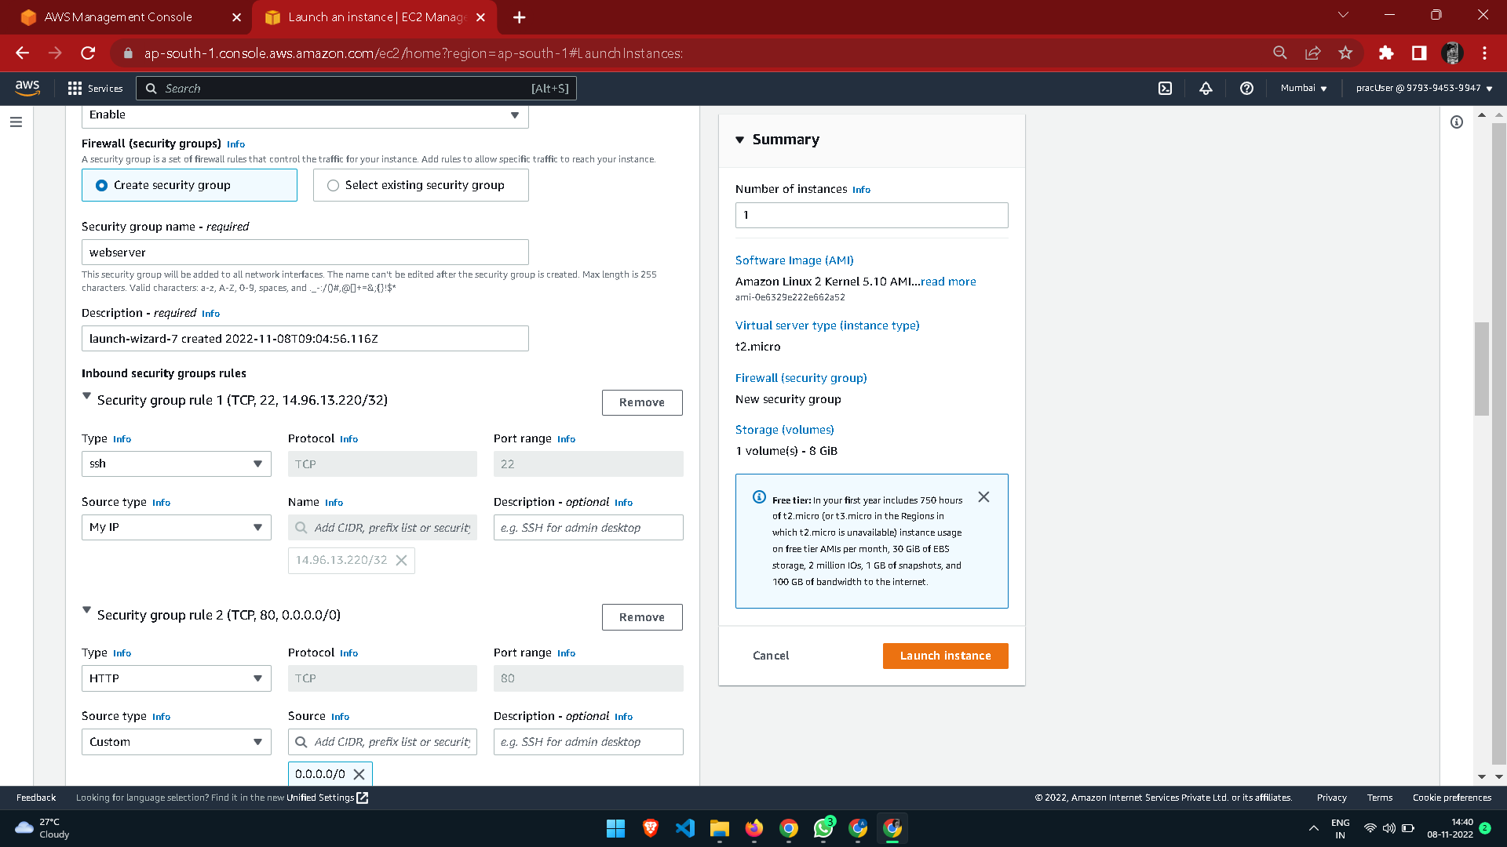

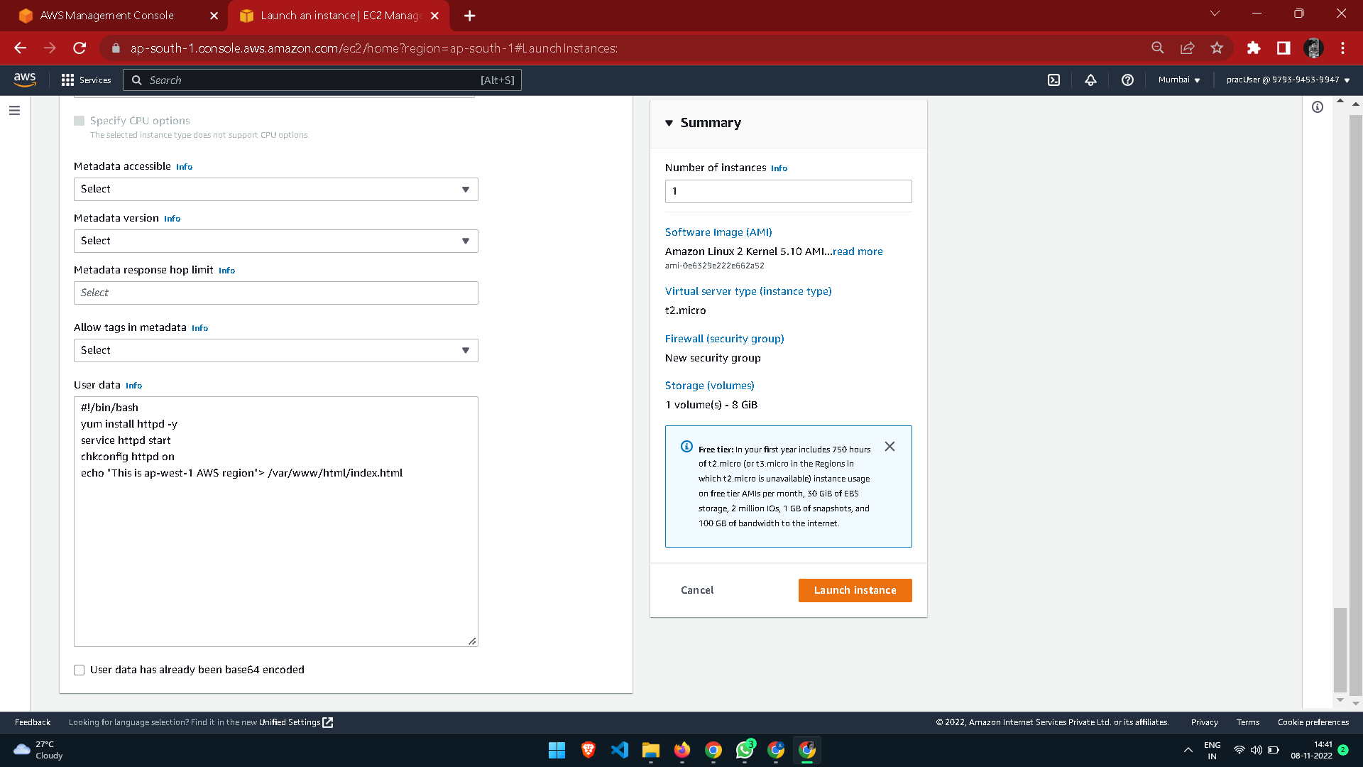

1. Create a public webserver in region 2.
2. Create a Route53 public hosted zone (e.g: Yourdomain.com).
3. Create 2 health checks for both the webservers.

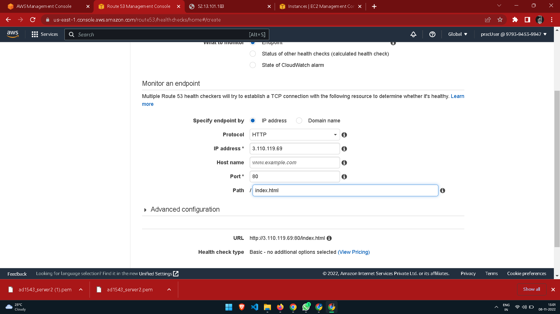

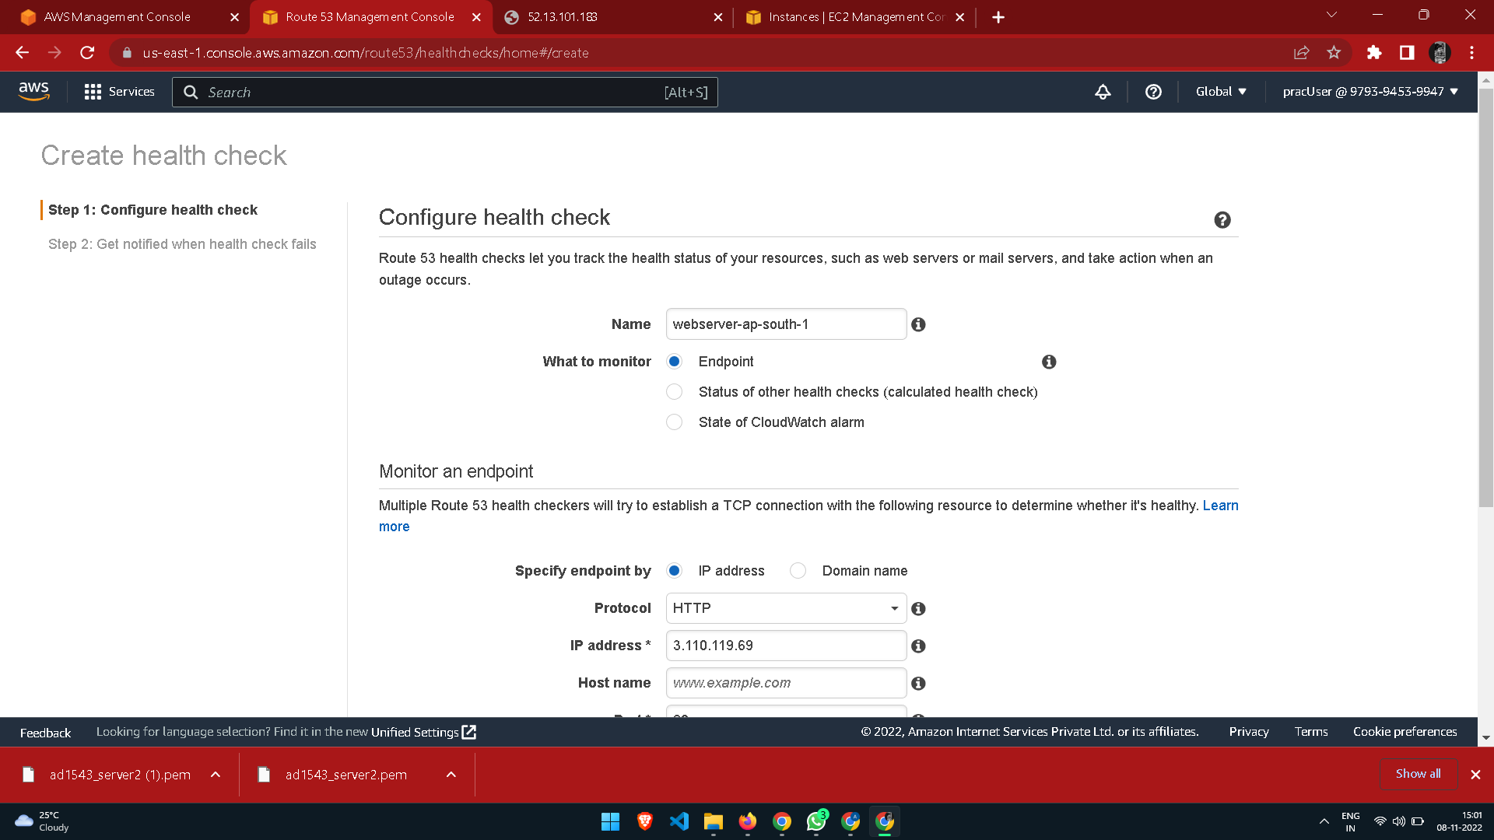

1. Create a subdomain A record test.yourdomain.com and configure it as failover routing (Primary).

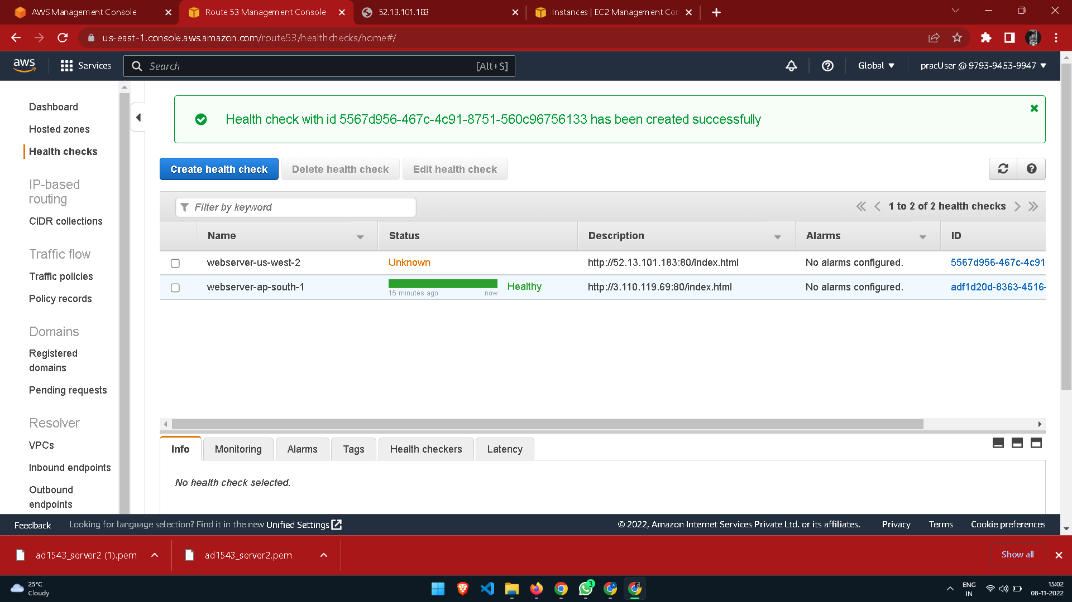

1. Create another same subdomain A record test.yourdomain.com and configure it as failover routing (secondary).

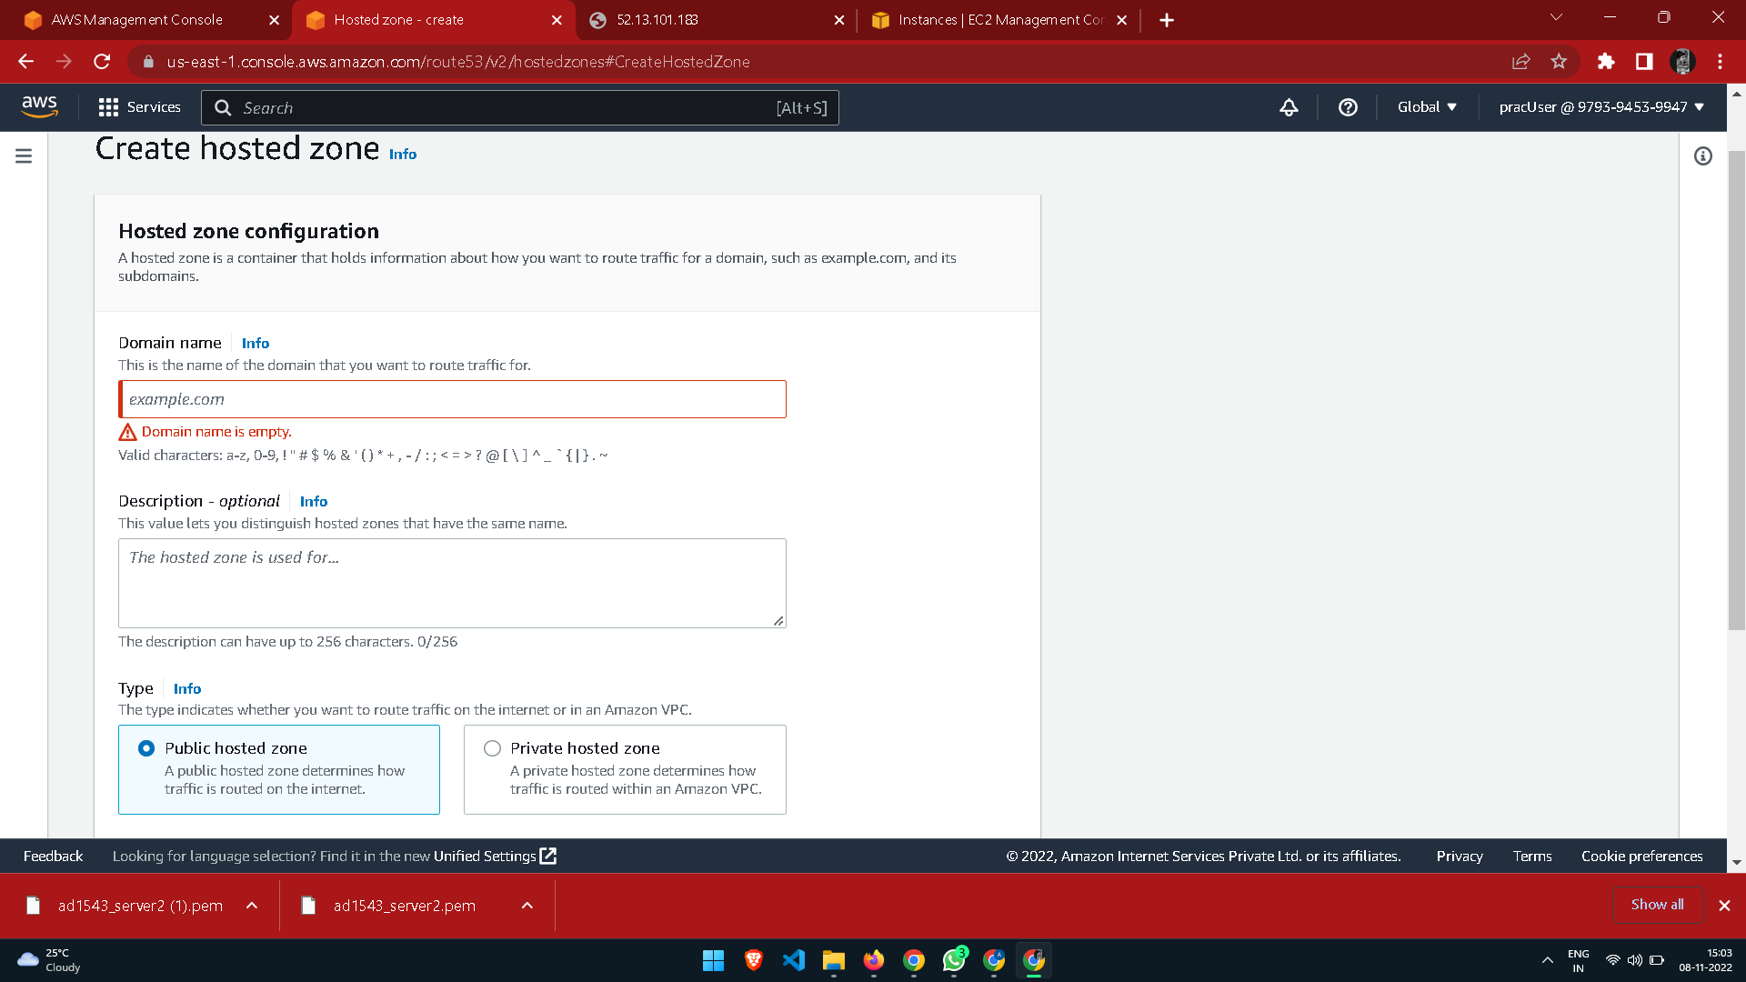

1. Test the connection by hitting http://test.yourdomain.com.
2. Login to primary webserver in region 1 and stop httpd service.
3. Wait for TTL to expire and see If you get redirected to another web server in region 2.

**Result:**

Hence, we have successfully configure DNS failover routing policy for Webservers across AWS Regions.